**Aditya Mhatre**

[**17033712@brookes.ac.uk**](mailto:17033712@brookes.ac.uk)

**Internship Test Part 1 – Optimum G**

Post Rig Software - Case Study

**Table of Contents**

**List of Figures** 2

1. Software Aim: 3

2. Input and Output Data 4

2.1. Input Data 4

2.2. Output Data 5

3. Case Study 6

3.1. Scenario 6

3.1.1. Road Car: 7

3.1.2. Race Car 8

3.1.3. Rally Car 8

# **List of Figures**

Figure 1: Model Outline 3

Figure 2: Sign Convention 3

Figure 3: Step Input 7

Figure 4: Road Car 7

Figure 5: Race Car 8

Figure 6: Rally Car 9

# Software Aim:

The software revolves around the assumption of a lumped mass attached to the road (base) supported on a spring and damper assembly as show in Figure 1.

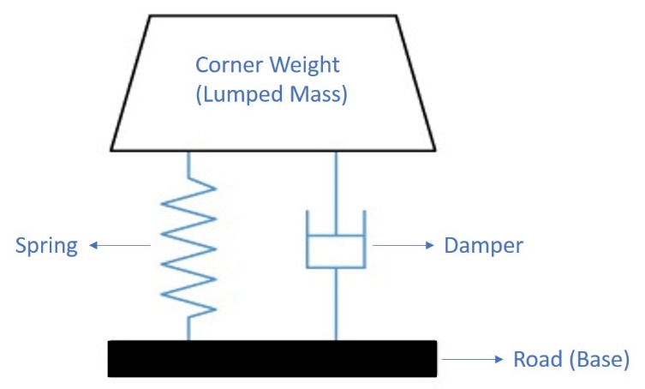

Figure 1: Model Outline

With this assumption, a corner of a car can be modelled as shown in Figure 1. The road in the model can be disturbed with different oscillation and study how the model behaves. In the software the body oscillates about its equilibrium position. The sign conventions for the motion of the body and the Spring and Damper forces in the software are show in Figure 2. The input disturbances are time vs road vertical displacement. The software can use a step signal or a user defined road profile to provide the input for the simulation.

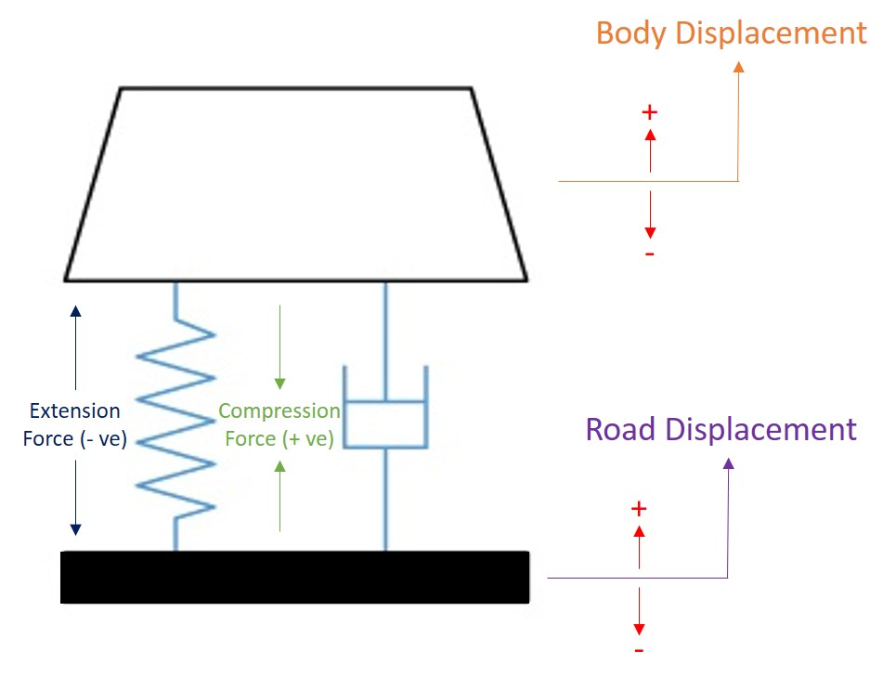

Figure 2: Sign Convention

# Input and Output Data

The Input data required for the software to run a simulation and the outputs generated by the software are explained in the Section 2.1 and Section 2.2.

## Input Data

A list of input the user must provide to successfully run the software Table 1.

|  |  |  |
| --- | --- | --- |
| **Design Data** | | |
| Parameter | Description | Unit |
| Mass | Corner weight of the vehicle | Kg |
| Spring Stiffness | Stiffness of the spring hold the mass | N/m |
| Damping Coefficient | Damping Coefficient of the damper | N/(m/s) |
| **Simulation Setup Data** | | |
| Time Frame | | |
| Start Time | The start time of the simulation | s |
| Time Step | The time between two successive time steps | s |
| End Time | The duration for which the simulation is intended to run | s |
| Step Input Signal | | |
| Step Amplitude | Amplitude of the Step Signal | m |
| Custom Input Signal | | |
| Custom Input | Import a time vs vertical Road displacement (in meters) data in CSV format | |

Table 1: Input Data

## Output Data

The output data and plots that the software displays are mentioned in Table 2

|  |  |
| --- | --- |
| **System Characteristics** | **Units** |
| Natural Frequency | Hz |
| Critical Damping | N/(m/s) |
| Damping Ratio | - |
| **Output Plots** | |
| Body Displacement (Time vs Body Vertical Displacement) | |
| Spring Force (Time vs Spring Force) | |
| Damper Force (Time vs Damper Force) | |
| Vertical Acceleration (Time vs Body Vertical Acceleration) | |

Table 2: Output Data

# Case Study

The case study in this document serves the purpose to explain how the software could be used to study the behaviour of a mass supported on a spring damper assembly to road disturbances. A Scenarios is studied in this case study; the response of 3 types of cars to a step input of 5 mm from the road.

## Scenario

In the first scenario the response of 3 car; Road Car, Race Car and Rally Car to a road disturbance in the for a step signal of amplitude 5 mm is studied. The values that define the 3 cars are assumed values just for the study. These are names given to 3 types of system; Road Car representing an Underdamped system, Race Car representing a Critically Damped and Rally Car representing an Overdamped system.

The 3 cars which define the 3 types of system have the same mass but different spring stiffness and damping coefficient.

|  |  |  |  |  |  |
| --- | --- | --- | --- | --- | --- |
| **Template** | **Corner Weight (kg)** | **Spring Stiffness (N/m)** | **Damping Coefficient (N/(m/s))** | **Damping Ratio** | **System Characteristics** |
| Road Car | 400 | 80000 | 4000 | 0.35 | Underdamped |
| Race Car | 400 | 120000 | 13850 | 1.00 | Critically Damped |
| Rally Car | 400 | 150000 | 17050 | 1.10 | Over Damped |

Table 3: Template Data

These cars are subjected to a step input of 5 mm through the road (Figure 3). The response of the body to the road disturbance given is observed within the software, through the results tab.

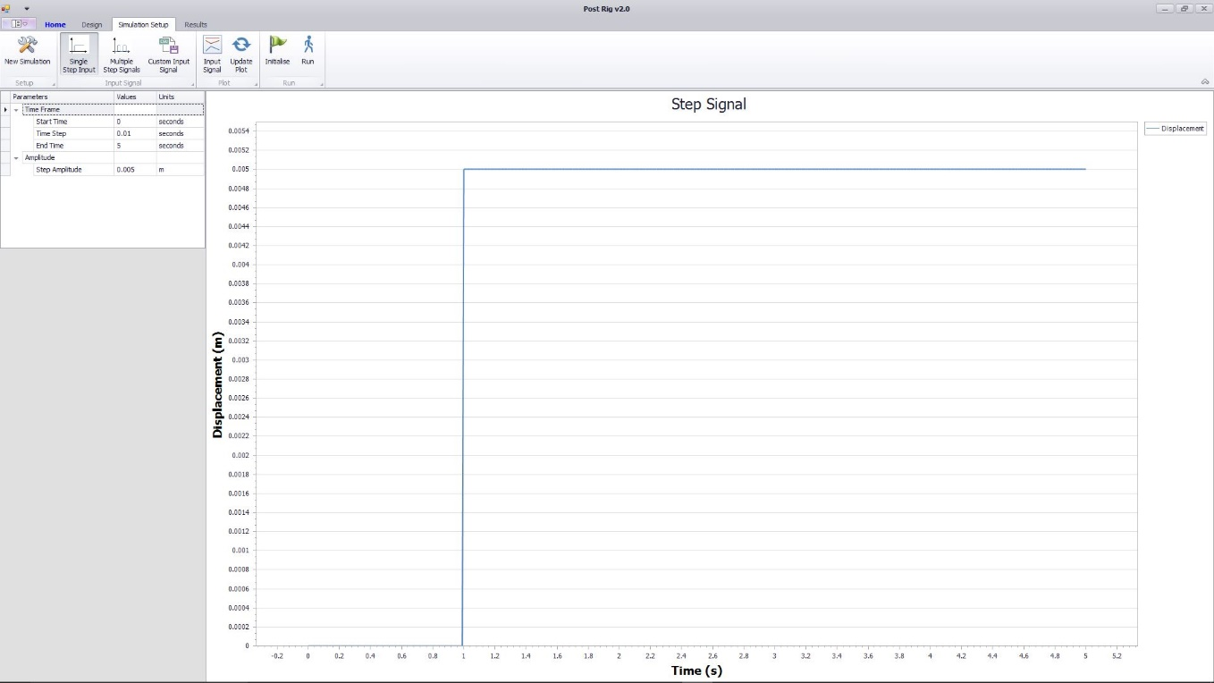

Figure 3: Step Input

## Road Car:

After being subjected to a step signal, it can be seen that the after the step input has been applied, the body oscillates for a small duration until the body motion dies down and it becomes stationary (Figure 4). From the results it can be seen that the body settles down and all the motion inherited from the step input have died down.

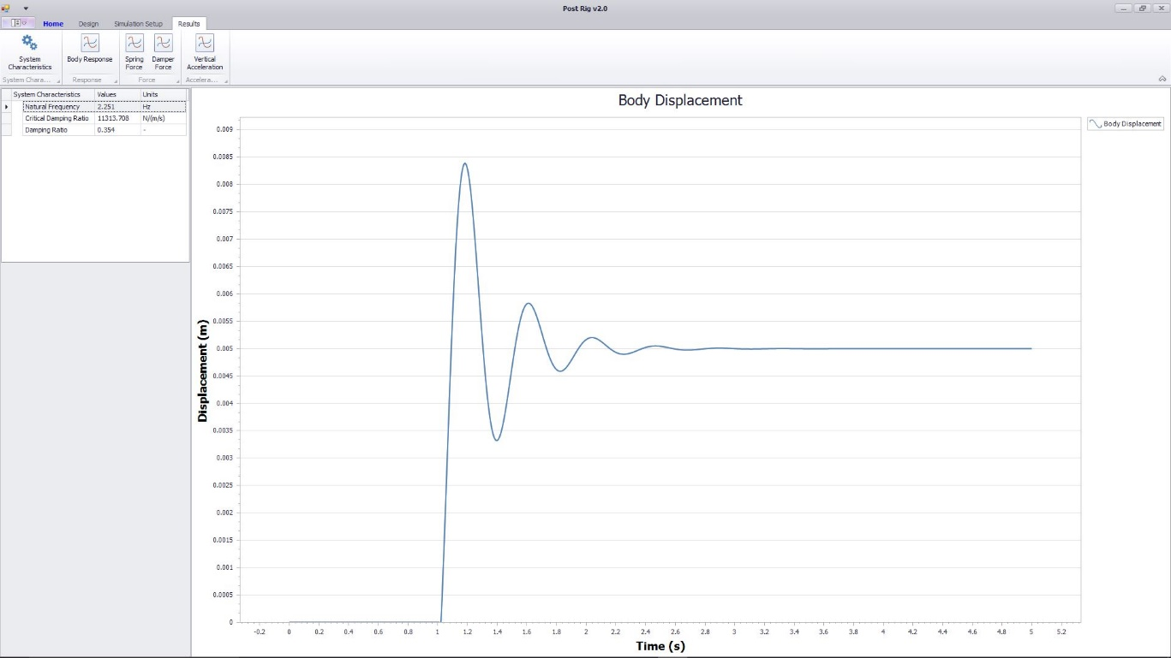

Figure 4: Road Car

There is an overshoot about a mean value and with each successive oscillation the amplitude of the body displacement reduces.

## Race Car

The Race Car is critically damped and is subjected to the same step signal as the road car. From the results it can be seen that body displacement is not the same as the road car. The body settles down quickly to a fixed value without undergoing a dying oscillation ().

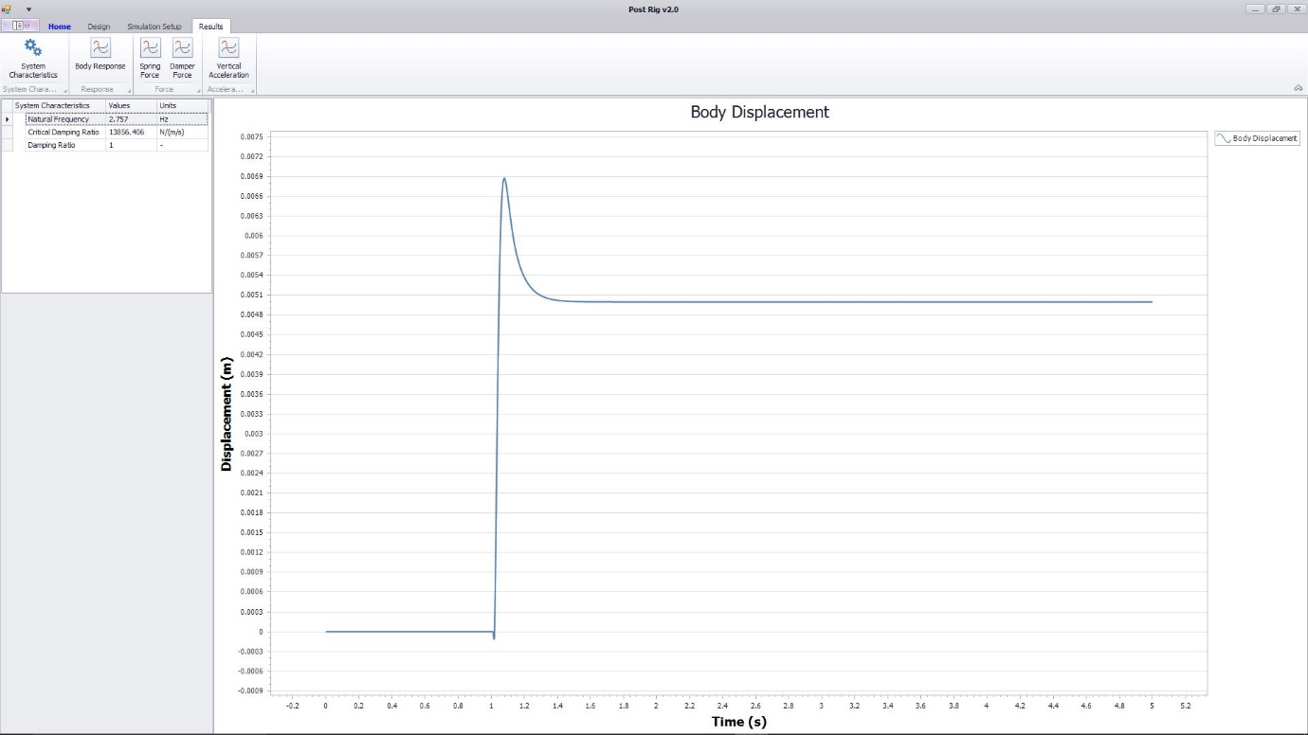

Figure 5: Race Car

## Rally Car

The Rally Car is also subjected to same step input that the Road Car and Race Car are subjected to. Similar to the Race Car, the body displacement of the Rally Car does not follow the same pattern as the Road Car. There is no overshoot but the body settles down to a fixed without going through a dying oscillation to settle down to a single value (Figure 6).

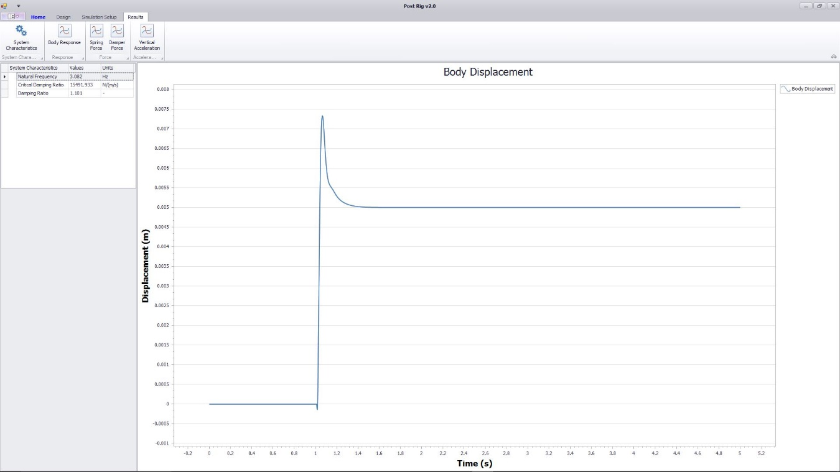

Figure 6: Rally Car